SAVEETHA INSTITUTE OF MEDICAL AND TECHNICAL SCIENCES
ASSIGNMENT – 2
Name | K Venkata Siva Prasad
Register Number | 192325106
Course Code | CSA43
Course Name | INTERNET PROGRAMMING

Question 1: Student Registration Form using DOM Manipulation and Regular Expressions

1.1 Aim
To develop a JavaScript program that validates the student name, email ID, mobile number and password of an online registration form by using DOM manipulation and Regular Expressions, and that displays suitable error messages without reloading the web page.

1.2.1 Document Object Model (DOM)
The DOM is a tree representation of an HTML document that the browser builds after loading the page. Every tag, attribute and piece of text becomes a node of this tree and JavaScript can read or change any node. Because the DOM is changed in the memory of the browser, the page is updated at once and no request is sent to the server. The DOM operations used in this program are given below.
DOM operation | Purpose | Used in the program
document.getElementById() | Selects one element by its id | Reading the value of every input box
element.value | Reads the text typed by the user | value.trim() of each field
element.textContent | Changes the text of a node safely | Showing the error or success message below a field
element.classList.add() / remove() | Changes the CSS class of an element | Green border for valid and red border for invalid input
element.style | Changes inline style | Width and colour of the password strength bar
document.createElement() | Creates a new node | List of errors and the success heading and paragraph
appendChild() | Adds a new node to the tree | Placing the created list items in the error summary
addEventListener() | Attaches an event handler | input, blur and submit events
event.preventDefault() | Stops the default browser action | Stops the form submission that would reload the page

1.2.2 Regular Expressions
A regular expression (RegExp) is a pattern that describes a set of strings. In JavaScript it is written between two slashes, and the method pattern.test(text) returns true when the whole text follows the pattern. The anchors ^ and $ are written at the start and the end so that the entire input, and not just a part of it, must match.
Symbol | Meaning
^ $ | Beginning and end of the text
[A-Za-z] | Any one letter from the range
[0-9] or \d | Any one digit
[6-9] | A digit from 6 to 9
{10} {8,20} | Exactly 10 times; between 8 and 20 times
+ * ? | One or more; zero or more; zero or one
(?:...) | Group without capturing
(?=...) | Look-ahead: checks that something follows without consuming it
\. | A literal dot (the dot alone means any character)

1.3 Validation Rules and Patterns
Field | Rule | Regular expression
Student name | Letters only, single spaces, dot or apostrophe between words; 3 to 40 characters | /^[A-Za-z]+(?:[ .'][A-Za-z]+)*$/
Email ID | Local part, @, domain, and an extension of at least 2 letters | /^[A-Za-z0-9._%+-]+@[A-Za-z0-9-]+(?:\.[A-Za-z0-9-]+)*\.[A-Za-z]{2,}$/
Mobile number | 10 digits starting with 6, 7, 8 or 9; optional +91 prefix | /^(?:\+91[- ]?)?[6-9][0-9]{9}$/
Password | 8 to 20 characters with a lowercase letter, an uppercase letter, a digit and a symbol | /^(?=.*[a-z])(?=.*[A-Z])(?=.*\d)(?=.*[^A-Za-z0-9\s]).{8,20}$/
Confirm password | Must be equal to the password | String comparison (p !== c)

The password pattern uses four look-aheads. Each one scans the entire password and checks for one kind of character, so that the order of the characters does not matter. The part .{8,20} then limits the length.

1.4 Algorithm
- Attach input and blur listeners to each field so that it is validated while the user types and when the user leaves the field.
- On every check read the value, trim the spaces and test it against the rule: empty, length, and pattern.
- Write the error or success text into the message element below the field and change the class of the input box.
- While typing the password, calculate the strength (length, mixed case, digit, symbol) and set the width of the strength bar.
- On the submit event call preventDefault(), run all the checks again, and count the invalid fields.
- If there are errors, create a list of them with createElement() and show it above the form. Otherwise create and display the success message.

1.5 Program (q1.html)
Source code
<!DOCTYPE html>
<html lang="en">
<head>
<meta charset="UTF-8">
<meta name="viewport" content="width=device-width, initial-scale=1.0">
<link rel="icon" href="data:,">
<title>Student Registration | DOM and RegExp Validation</title>
<style>
* { box-sizing: border-box; }
body { margin: 0; min-height: 100vh; font-family: "Segoe UI", Arial, sans-serif; background: linear-gradient(135deg, #e3f2fd, #ede7f6); display: flex; justify-content: center; padding: 30px 12px; }
.box { width: 480px; background: #fff; border-radius: 12px; padding: 26px 30px 30px; box-shadow: 0 6px 24px rgba(40, 53, 147, .18); height: fit-content; }
h1 { margin: 0 0 4px; font-size: 24px; color: #283593; }
.sub { margin: 0 0 18px; color: #607d8b; font-size: 14px; }
.field { margin-bottom: 14px; }
label { display: block; font-size: 14px; font-weight: 600; margin-bottom: 4px; color: #37474f; }
input { width: 100%; padding: 10px 12px; border: 2px solid #cfd8dc; border-radius: 7px; font-size: 15px; outline: none; transition: border-color .2s, background .2s; }
input:focus { border-color: #5c6bc0; }
input.valid { border-color: #2e7d32; background: #f1f8e9; }
input.invalid { border-color: #c62828; background: #fff5f5; }
.msg { font-size: 13px; margin-top: 4px; min-height: 16px; }
.msg.err { color: #c62828; }
.msg.ok { color: #2e7d32; }
.meter { height: 7px; background: #eceff1; border-radius: 4px; margin-top: 6px; overflow: hidden; }
.meter span { display: block; height: 100%; width: 0; transition: width .3s, background .3s; }
button { width: 100%; padding: 12px; border: 0; border-radius: 8px; background: #3949ab; color: #fff; font-size: 16px; font-weight: 600; cursor: pointer; }
button:hover { background: #283593; }
#summary { margin-bottom: 14px; padding: 10px 14px; border-radius: 8px; background: #ffebee; color: #b71c1c; font-size: 14px; display: none; }
#summary ul { margin: 6px 0 0; padding-left: 20px; }
#success { display: none; background: #e8f5e9; border: 1px solid #66bb6a; color: #1b5e20; padding: 14px 16px; border-radius: 8px; margin-top: 16px; font-size: 14px; }
#success h3 { margin: 0 0 6px; }
</style>
</head>
<body>
<div class="box">
<h1>Student Online Registration</h1>
<p class="sub">Validated with DOM manipulation and Regular Expressions. The page never reloads.</p>

<div id="summary"></div>

<form id="regForm" novalidate>
<div class="field">
<label for="name">Student Name</label>
<input type="text" id="name" placeholder="e.g. Venkata Siva Prasad" autocomplete="off">
<div class="msg" id="name-msg"></div>
</div>
<div class="field">
<label for="email">Email ID</label>
<input type="text" id="email" placeholder="name@example.com" autocomplete="off">
<div class="msg" id="email-msg"></div>
</div>
<div class="field">
<label for="mobile">Mobile Number</label>
<input type="text" id="mobile" placeholder="10 digit number starting with 6-9" autocomplete="off" maxlength="12">
<div class="msg" id="mobile-msg"></div>
</div>
<div class="field">
<label for="password">Password</label>
<input type="password" id="password" placeholder="Minimum 8 characters">
<div class="meter"><span id="bar"></span></div>
<div class="msg" id="password-msg"></div>
</div>
<div class="field">
<label for="confirm">Confirm Password</label>
<input type="password" id="confirm" placeholder="Re-enter the password">
<div class="msg" id="confirm-msg"></div>
</div>
<button type="submit">Register</button>
</form>

<div id="success"></div>
</div>

<script>
// ---------- Regular expressions ----------
var RULES = {
name: { re: /^[A-Za-z]+(?:[ .'][A-Za-z]+)*$/, min: 3, max: 40,
empty: 'Name is required.',
bad: 'Use letters and single spaces only (no digits or symbols), 3 to 40 characters.' },
email: { re: /^[A-Za-z0-9._%+-]+@[A-Za-z0-9-]+(?:\.[A-Za-z0-9-]+)*\.[A-Za-z]{2,}$/,
empty: 'Email ID is required.',
bad: 'Enter a valid email such as name@example.com.' },
mobile: { re: /^(?:\+91[- ]?)?[6-9][0-9]{9}$/,
empty: 'Mobile number is required.',
bad: 'Enter 10 digits starting with 6, 7, 8 or 9 (optional +91).' },
password: { re: /^(?=.*[a-z])(?=.*[A-Z])(?=.*\d)(?=.*[^A-Za-z0-9\s]).{8,20}$/,
empty: 'Password is required.',
bad: 'Need 8-20 characters with an uppercase, a lowercase, a digit and a symbol.' }
};

// ---------- DOM helpers ----------
function $(id) { return document.getElementById(id); }

function show(id, ok, text) {
var input = $(id), msg = $(id + '-msg');
input.classList.remove('valid', 'invalid');
input.classList.add(ok ? 'valid' : 'invalid');
msg.textContent = text; // change text of an existing node
msg.className = 'msg ' + (ok ? 'ok' : 'err'); // change class
return ok;
}

function check(id) {
var value = $(id).value.trim(), r = RULES[id];
if (value === '') return show(id, false, r.empty);
if (r.min && (value.length < r.min || value.length > r.max)) return show(id, false, r.bad);
if (!r.re.test(value)) return show(id, false, r.bad);
return show(id, true, 'Looks good.');
}

function checkConfirm() {
var p = $('password').value, c = $('confirm').value;
if (c === '') return show('confirm', false, 'Please confirm the password.');
if (p !== c) return show('confirm', false, 'Passwords do not match.');
return show('confirm', true, 'Passwords match.');
}

function strength(p) {
var s = 0;
if (p.length >= 8) s++;
if (/[a-z]/.test(p) && /[A-Z]/.test(p)) s++;
if (/\d/.test(p)) s++;
if (/[^A-Za-z0-9]/.test(p)) s++;
var bar = $('bar');
bar.style.width = (s * 25) + '%';
bar.style.background = ['#eceff1', '#e53935', '#fb8c00', '#fdd835', '#43a047'][s];
}

// ---------- Events ----------
['name', 'email', 'mobile', 'password'].forEach(function (id) {
$(id).addEventListener('input', function () { if (id === 'password') strength(this.value); check(id); if ($('confirm').value) checkConfirm(); });
$(id).addEventListener('blur', function () { check(id); });
});
$('confirm').addEventListener('input', checkConfirm);

$('regForm').addEventListener('submit', function (e) {
e.preventDefault(); // stop the page reload
var results = {
'Student name': check('name'), 'Email ID': check('email'), 'Mobile number': check('mobile'),
'Password': check('password'), 'Confirm password': checkConfirm()
};
var summary = $('summary'), success = $('success');
summary.innerHTML = ''; success.innerHTML = '';

var errors = Object.keys(results).filter(function (k) { return !results[k]; });
if (errors.length) {
summary.style.display = 'block'; success.style.display = 'none';
summary.appendChild(document.createTextNode('Please correct ' + errors.length + ' field(s):'));
var ul = document.createElement('ul'); // create new DOM nodes
errors.forEach(function (k) { var li = document.createElement('li'); li.textContent = k; ul.appendChild(li); });
summary.appendChild(ul);
return;
}
summary.style.display = 'none';
var h = document.createElement('h3'); h.textContent = 'Registration successful';
var p = document.createElement('p');
p.textContent = 'Welcome, ' + $('name').value.trim() + '. A confirmation will be sent to ' + $('email').value.trim() + ' and ' + $('mobile').value.trim() + '.';
success.appendChild(h); success.appendChild(p);
success.style.display = 'block';
});
</script>
</body>
</html>

1.6 Output
The program was opened in Google Chrome and different test inputs were typed into the form.
Test 1: Empty form when the page opens.
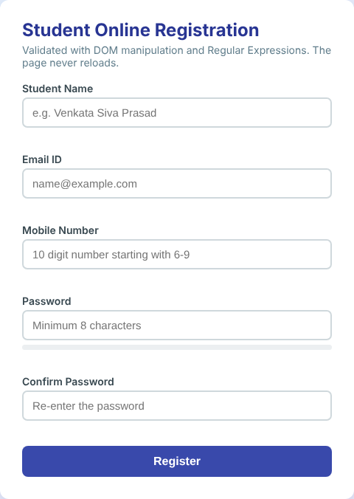
Test 2: Invalid values. Name with digits, email without extension, a short mobile number, a short password and different confirm password.
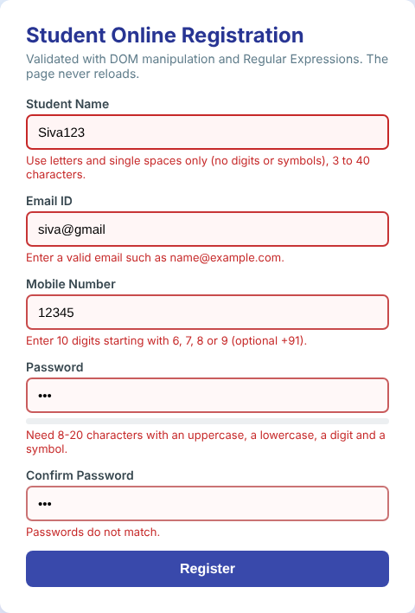
Test 3: Password with letters and digits but no symbol. The strength bar is yellow and the rule message stays.

Test 4: Register button pressed with errors. A summary of all the wrong fields is created by DOM manipulation and the page is not reloaded.
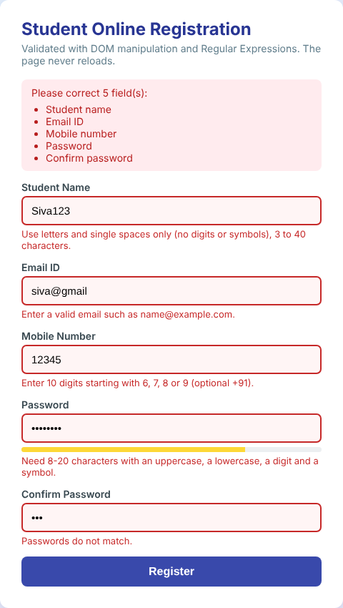
Test 5: All fields corrected. Every box turns green.
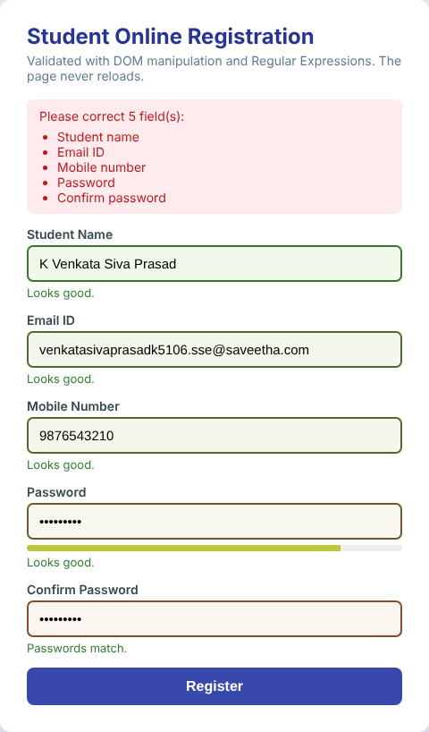
Test 6: Register button pressed with valid data. The success message appears below the form.
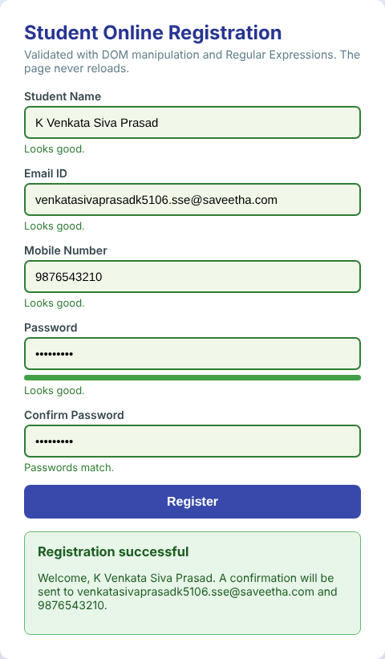

1.7 Regular Expression Test Results
The patterns were also tested directly in the browser with sample strings. The results below were returned by the running page.
Field | Test string | Expected | Result of test()
Mobile | 9876543210 | Valid | true
Mobile | 5876543210 (starts with 5) | Invalid | false
Mobile | 98765 (too short) | Invalid | false
Mobile | +91 9876543210 | Valid | true
Email | a.b@x.co.in | Valid | true
Email | a@b (no extension) | Invalid | false
Email | @x.com (no local part) | Invalid | false
Name | Anitha R | Valid | true
Name | R2D2 (digits) | Invalid | false
Password | Aa1@aaaa | Valid | true
Password | aaaaaaaa (no uppercase, digit or symbol) | Invalid | false

1.8 Result
The registration form was developed and tested. Student name, email ID, mobile number and password were validated with regular expressions, and the error messages, colour changes, strength bar and success message were produced by DOM manipulation. The browser address stayed the same after pressing the Register button, which proves that the page was not reloaded.
Question 2: E-commerce Dynamic Product Search using JavaScript DOM and AJAX with JSON

2.1 Aim
To develop an e-commerce product search web page that uses AJAX to retrieve product details in JSON format from a server and uses the DOM to display the matching products dynamically while the user is typing a product name.

2.2 Theory

2.2.1 AJAX
AJAX (Asynchronous JavaScript and XML) is a technique in which JavaScript sends a request to the server in the background and receives the data without reloading the page. The word asynchronous means that the browser keeps responding to the user while the request is being processed. Although XML is in the name, today JSON is the commonly used data format. In a shopping site AJAX is used for search suggestions, filters, cart updates and pagination.

2.2.2 JSON
JavaScript Object Notation (JSON) is a light text format for data exchange. It is built from name–value pairs in braces and ordered lists in square brackets. JSON.parse(text) converts the JSON text into a JavaScript object and JSON.stringify(object) does the reverse. It is smaller and easier to process than XML.

2.2.3 Working of the live search
- The user types a letter in the search box and the input event is fired.
- A debounce timer waits for 250 milliseconds after the last key press, so that the server is not called for every single key stroke.
- An XMLHttpRequest object sends a GET request to /api/products?q=text. An older unfinished request is cancelled with abort().
- The Python server (server.py) filters the product list stored in products.json by name or category and answers with JSON.
- When readyState is 4 and status is 200, the response is converted with JSON.parse().
- The render() function builds a card for every matching product with createElement() and appendChild() and highlights the typed text with a mark element.
- If no product matches, a friendly "No products match" message is shown.

2.3 Files Used
File | Role
q2.html | Search page: input box, AJAX request and DOM rendering (client side)
server.py | Web server that serves the files and the /api/products?q= service (server side)
products.json | Database of 16 products with name, category, price, rating and stock

2.4 Programs
q2.html
<!DOCTYPE html>
<html lang="en">
<head>
<meta charset="UTF-8">
<meta name="viewport" content="width=device-width, initial-scale=1.0">
<link rel="icon" href="data:,">
<title>TechKart | Live Product Search (AJAX)</title>
<style>
* { box-sizing: border-box; }
body { margin: 0; font-family: "Segoe UI", Arial, sans-serif; background: #f1f3f6; color: #212121; }
header { background: #2874f0; color: #fff; padding: 14px 40px; display: flex; align-items: center; gap: 28px; }
header h1 { margin: 0; font-size: 24px; font-style: italic; }
.search { flex: 1; max-width: 620px; position: relative; }
.search input { width: 100%; padding: 11px 16px; border: 0; border-radius: 3px; font-size: 16px; outline: none; }
.status { font-size: 13px; color: #e3f2fd; min-width: 150px; }
main { max-width: 1100px; margin: 0 auto; padding: 18px 24px; }
#info { font-size: 14px; color: #546e7a; margin-bottom: 12px; min-height: 20px; }
#results { display: grid; grid-template-columns: repeat(4, 1fr); gap: 14px; }
.card { background: #fff; border-radius: 6px; padding: 14px; box-shadow: 0 1px 4px rgba(0, 0, 0, .15); text-align: center; transition: transform .15s, box-shadow .15s; }
.card:hover { transform: translateY(-4px); box-shadow: 0 8px 16px rgba(0, 0, 0, .18); }
.icon { font-size: 52px; line-height: 70px; }
.card h3 { margin: 6px 0 2px; font-size: 15px; }
.cat { font-size: 12px; color: #78909c; }
.price { font-size: 18px; font-weight: 700; margin-top: 6px; }
.rate { display: inline-block; background: #388e3c; color: #fff; font-size: 12px; font-weight: 700; padding: 1px 7px; border-radius: 3px; margin-top: 6px; }
.stock { font-size: 12px; color: #d84315; margin-top: 4px; }
mark { background: #fff59d; padding: 0; }
.empty { grid-column: 1 / -1; text-align: center; padding: 50px 0; color: #78909c; font-size: 17px; }
.chips { margin-bottom: 14px; }
.chips span { display: inline-block; background: #fff; border: 1px solid #cfd8dc; border-radius: 16px; padding: 4px 14px; margin-right: 8px; font-size: 13px; cursor: pointer; }
.chips span:hover { background: #e3f2fd; }
</style>
</head>
<body>

<header>
<h1>TechKart</h1>
<div class="search"><input id="q" type="text" placeholder="Search for products, brands and categories" autocomplete="off" autofocus></div>
<div class="status" id="status">Ready</div>
</header>

<main>
<div class="chips" id="chips"><span>audio</span><span>mobiles</span><span>smart</span><span>accessories</span></div>
<div id="info">Start typing a product name. Results are fetched from the server as you type.</div>
<div id="results"></div>
</main>

<script>
var input = document.getElementById('q');
var results = document.getElementById('results');
var info = document.getElementById('info');
var statusBox = document.getElementById('status');
var timer = null, lastRequest = null;

// Debounce: wait 250 ms after the last key press before calling the server
input.addEventListener('input', function () {
clearTimeout(timer);
timer = setTimeout(function () { search(input.value.trim()); }, 250);
});

// Category chips fill the search box
document.getElementById('chips').addEventListener('click', function (e) {
if (e.target.tagName === 'SPAN') { input.value = e.target.textContent; search(input.value); }
});

// ---------- AJAX request ----------
function search(text) {
if (text === '') { results.innerHTML = ''; info.textContent = 'Start typing a product name. Results are fetched from the server as you type.'; statusBox.textContent = 'Ready'; return; }

if (lastRequest) lastRequest.abort(); // cancel an older, slower request
var xhr = new XMLHttpRequest();
lastRequest = xhr;
xhr.open('GET', '/api/products?q=' + encodeURIComponent(text), true); // asynchronous
statusBox.textContent = 'Searching...';

xhr.onreadystatechange = function () {
if (xhr.readyState === 4 && xhr.status === 200) {
var data = JSON.parse(xhr.responseText); // JSON text -> JavaScript object
render(data.products, text);
statusBox.textContent = 'Server replied (200 OK)';
}
};
xhr.onerror = function () { statusBox.textContent = 'Network error'; info.textContent = 'Could not reach the server.'; };
xhr.send();
}

// ---------- DOM update ----------
function highlight(textValue, term) {
var i = textValue.toLowerCase().indexOf(term.toLowerCase());
if (i < 0) return document.createTextNode(textValue);
var span = document.createElement('span');
span.appendChild(document.createTextNode(textValue.slice(0, i)));
var m = document.createElement('mark');
m.textContent = textValue.slice(i, i + term.length);
span.appendChild(m);
span.appendChild(document.createTextNode(textValue.slice(i + term.length)));
return span;
}

function render(products, term) {
results.innerHTML = '';
info.textContent = products.length + ' product(s) found for "' + term + '"';
if (products.length === 0) {
var d = document.createElement('div'); d.className = 'empty';
d.textContent = 'No products match "' + term + '". Try another name.';
results.appendChild(d);
return;
}
products.forEach(function (p) {
var card = document.createElement('div'); card.className = 'card';

var icon = document.createElement('div'); icon.className = 'icon'; icon.textContent = p.icon;
var h = document.createElement('h3'); h.appendChild(highlight(p.name, term));
var cat = document.createElement('div'); cat.className = 'cat'; cat.textContent = p.category;
var price = document.createElement('div'); price.className = 'price'; price.textContent = '₹' + p.price.toLocaleString('en-IN');
var rate = document.createElement('span'); rate.className = 'rate'; rate.textContent = p.rating + ' ★';
var stock = document.createElement('div'); stock.className = 'stock';
stock.textContent = p.stock < 15 ? 'Only ' + p.stock + ' left' : '';

[icon, h, cat, price, rate, stock].forEach(function (n) { card.appendChild(n); });
results.appendChild(card);
});
}
</script>
</body>
</html>

server.py
"""server.py - small web server used for the AJAX programs (Q2 and Q3).
Serves the static files of this folder and one JSON API:
/api/products?q=<text> returns the products whose name or category contains the text
/api/slow waits 1.5 seconds and then answers (to watch readyState 3)
Run: python3 server.py and open http://localhost:8800/
"""
import json, time, sys
from http.server import SimpleHTTPRequestHandler, ThreadingHTTPServer
from urllib.parse import urlparse, parse_qs

with open('products.json', encoding='utf-8') as f:
PRODUCTS = json.load(f)

class Handler(SimpleHTTPRequestHandler):
def do_GET(self):
url = urlparse(self.path)
if url.path == '/api/products':
q = parse_qs(url.query).get('q', [''])[0].strip().lower()
found = [p for p in PRODUCTS if q in p['name'].lower() or q in p['category'].lower()] if q else []
self.reply(200, {'query': q, 'count': len(found), 'products': found})
elif url.path == '/api/slow':
time.sleep(1.5)
self.reply(200, {'message': 'Response sent after a 1.5 second delay'})
else:
super().do_GET()

def reply(self, code, data):
body = json.dumps(data).encode('utf-8')
self.send_response(code)
self.send_header('Content-Type', 'application/json')
self.send_header('Content-Length', str(len(body)))
self.end_headers()
self.wfile.write(body)

def log_message(self, *args):
pass

if __name__ == '__main__':
port = int(sys.argv[1]) if len(sys.argv) > 1 else 8800
ThreadingHTTPServer(('127.0.0.1', port), Handler).serve_forever()

products.json
[
{ "id": 1, "name": "Boat Rockerz 450 Headphones", "category": "Audio", "price": 1499, "rating": 4.2, "stock": 35, "icon": "🎧" },
{ "id": 2, "name": "Noise ColorFit Smart Watch", "category": "Wearables", "price": 2999, "rating": 4.1, "stock": 18, "icon": "⌚" },
{ "id": 3, "name": "Redmi 12 5G Smartphone", "category": "Mobiles", "price": 11999, "rating": 4.3, "stock": 22, "icon": "📱" },
{ "id": 4, "name": "HP 15s Laptop", "category": "Computers", "price": 42990, "rating": 4.4, "stock": 9, "icon": "💻" },
{ "id": 5, "name": "Logitech Wireless Mouse", "category": "Accessories", "price": 799, "rating": 4.5, "stock": 60, "icon": "🖱️" },
{ "id": 6, "name": "Mechanical Keyboard Blue", "category": "Accessories", "price": 2499, "rating": 4.3, "stock": 27, "icon": "⌨️" },
{ "id": 7, "name": "Canon EOS Camera Kit", "category": "Cameras", "price": 52990, "rating": 4.6, "stock": 5, "icon": "📷" },
{ "id": 8, "name": "JBL Go 3 Bluetooth Speaker", "category": "Audio", "price": 2799, "rating": 4.5, "stock": 41, "icon": "🔊" },
{ "id": 9, "name": "Samsung 27 inch Monitor", "category": "Computers", "price": 13499, "rating": 4.2, "stock": 14, "icon": "🖥️" },
{ "id": 10, "name": "Realme Buds Air Earbuds", "category": "Audio", "price": 1999, "rating": 4.0, "stock": 52, "icon": "🎧" },
{ "id": 11, "name": "Mi Power Bank 20000 mAh", "category": "Accessories", "price": 1899, "rating": 4.4, "stock": 70, "icon": "🔋" },
{ "id": 12, "name": "iQOO Z9 Smartphone", "category": "Mobiles", "price": 17999, "rating": 4.4, "stock": 16, "icon": "📱" },
{ "id": 13, "name": "Lenovo Tab M10 Tablet", "category": "Computers", "price": 12999, "rating": 4.1, "stock": 12, "icon": "📲" },
{ "id": 14, "name": "Fire-Boltt Smart Band", "category": "Wearables", "price": 1299, "rating": 3.9, "stock": 44, "icon": "⌚" },
{ "id": 15, "name": "TP-Link WiFi Router", "category": "Networking", "price": 1699, "rating": 4.3, "stock": 31, "icon": "📡" },
{ "id": 16, "name": "Sandisk 128 GB Pen Drive", "category": "Accessories", "price": 899, "rating": 4.6, "stock": 88, "icon": "💾" }
]

2.5 Output
The server was started with the command python3 server.py and the page was opened at http://localhost:8800/q2.html.
Test 1: Page when it is opened. No request is sent until the user types.
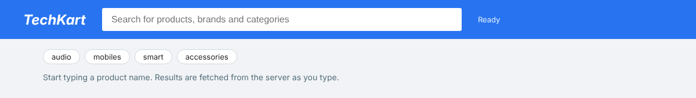
Test 2: Search for "audio". Three products of the Audio category are returned.
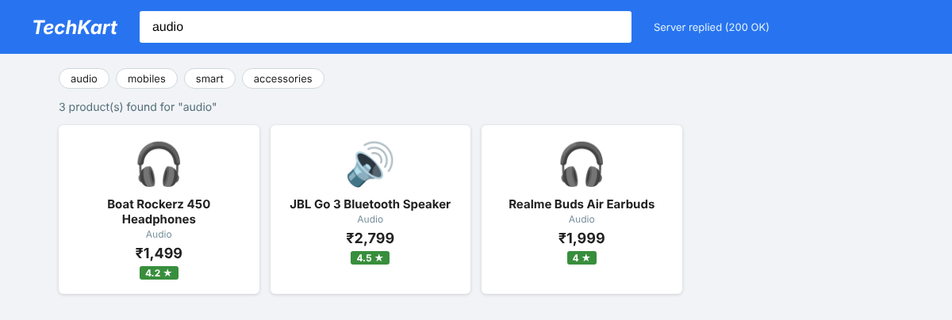
Test 3: Search for "smart". The matching letters are highlighted in the product names.
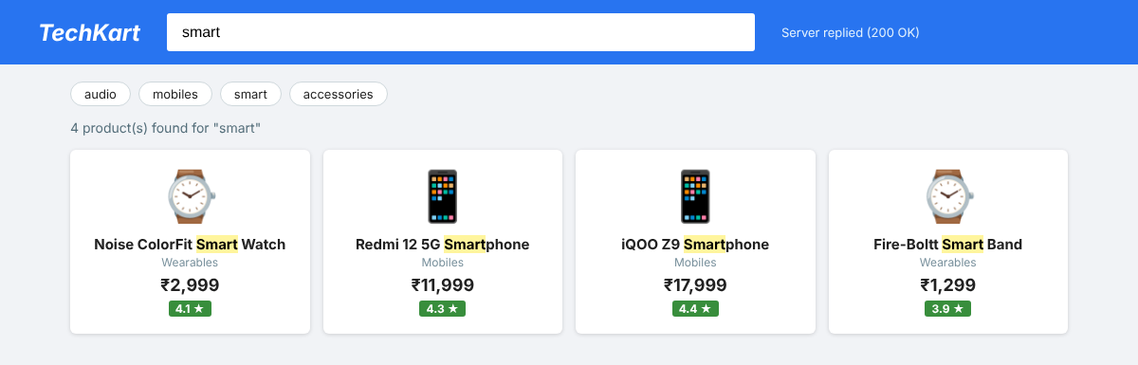
Test 4: Search for "lap". The result list shrinks to one product as the text becomes more specific.
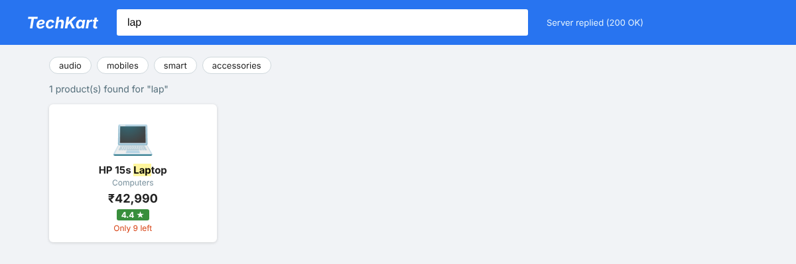
Test 5: Search for a product that does not exist.
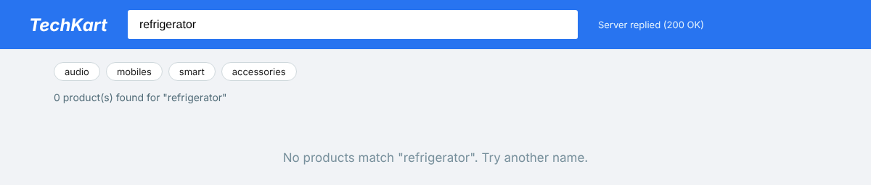
The raw JSON answer of the server for the search text "lap", which is what the JavaScript receives and converts with JSON.parse():
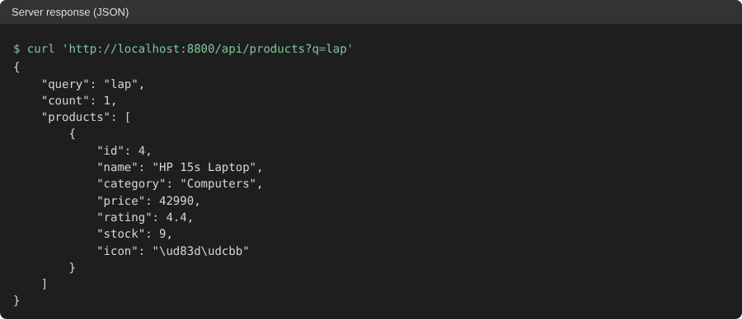

2.6 Explanation
- The address of the page never changed during the tests, and the header and search box stayed in place; only the product area changed. This is the effect of AJAX.
- The status text in the header changes from "Searching..." to "Server replied (200 OK)", which shows the xhr.readyState === 4 and xhr.status === 200 condition.
- The cards are not written in the HTML file. They are created at run time from the JSON data, so any change in products.json is shown without editing the page.
- The product text is inserted with textContent and not innerHTML, which also prevents script injection through product names.

2.7 Result
The dynamic product search page was developed. JSON product details were retrieved from the server by AJAX and the matching products were displayed dynamically through DOM manipulation while the user typed, without reloading the page.

Question 3: XMLHttpRequest Object, readyState Properties and Callback Methods in AJAX

3.1 Aim
To discuss the significance of the XMLHttpRequest object, its readyState property and callback methods, and to illustrate the working of AJAX with a suitable JavaScript program.

3.2 Significance of the XMLHttpRequest Object
XMLHttpRequest (XHR) is the built-in browser object that sends HTTP requests from JavaScript and receives the response without reloading the page. It was the first object that made AJAX possible and it is the base of the later fetch() API. Its significance is as follows:
- It allows a page to update a part of itself with new data, so that the user does not lose the scroll position or the typed data.
- It works asynchronously, so the user interface does not freeze while the server is working.
- It can request any type of data: plain text, HTML, XML and JSON, and can use the GET, POST, PUT and DELETE methods.
- It reduces the network traffic and the load on the server, because only the required data and not the whole page is transferred.
- It gives progress and error information through its events and gives access to the status code and response headers.
- It is supported by all browsers, so no plug-in or library is required.

3.3 Creating and Sending a Request
Step | Code | Explanation
1. Create the object | var xhr = new XMLHttpRequest(); | Makes a new request object
2. Set the callback | xhr.onreadystatechange = function () {...}; | Function that is called on every state change
3. Open the request | xhr.open("GET", "students.json", true); | Method, URL and async flag (true = asynchronous)
4. Send the request | xhr.send(); | Sends it (send(data) for POST)
5. Handle the response | xhr.responseText, xhr.status | Read the data when readyState is 4

3.4 readyState Property
The readyState property shows in which stage of its life the request is. Its value changes from 0 to 4 and the onreadystatechange callback is called each time the value changes.
Value | Name | Meaning
0 | UNSENT | The XMLHttpRequest object has been created, but open() has not been called
1 | OPENED | open() has been called; the request can be configured and send() can be called
2 | HEADERS_RECEIVED | send() has been called; the response headers and the status are available
3 | LOADING | The response body is being downloaded; responseText holds partial data
4 | DONE | The whole operation is complete (success or failure)

Related properties are status (200 OK, 404 Not Found, 500 Server Error), statusText, responseText, responseXML, responseType, timeout and the method getResponseHeader(). A request is successful when readyState is 4 and the status is between 200 and 299.

3.5 Callback Methods (Event Handlers)
A callback is a function that is given to the XHR object and is called later by the browser when something happens. Because AJAX does not wait for the server, callbacks are the way to run code at the right time.
Callback | Called when
onreadystatechange | The readyState value changes (most commonly used)
onload | The request completed successfully (readyState 4)
onerror | A network error occurred and the request could not be made
onprogress | Data is being received; gives the loaded and total bytes
ontimeout | The time given in xhr.timeout expired
onabort | The request was cancelled with abort()
onloadend | The request ended, with success or with failure

The program also uses a callback pattern of its own: the function ajaxGet(url, onSuccess, onFailure) receives two functions as parameters. The function that is called depends on the status code, so the same AJAX code can be reused for any request.

3.6 Programs
q3.html
<!DOCTYPE html>
<html lang="en">
<head>
<meta charset="UTF-8">
<meta name="viewport" content="width=device-width, initial-scale=1.0">
<link rel="icon" href="data:,">
<title>XMLHttpRequest Lab | AJAX</title>
<style>
* { box-sizing: border-box; }
body { margin: 0; font-family: "Segoe UI", Arial, sans-serif; background: #eef2f7; color: #263238; padding: 24px; }
h1 { margin: 0 0 4px; font-size: 24px; color: #1a237e; }
.sub { margin: 0 0 18px; color: #607d8b; font-size: 14px; }
.wrap { display: grid; grid-template-columns: 1fr 1.35fr; gap: 18px; max-width: 1150px; margin: 0 auto; }
.panel { background: #fff; border-radius: 10px; padding: 16px 20px; box-shadow: 0 2px 8px rgba(0, 0, 0, .12); }
.panel h2 { margin: 0 0 10px; font-size: 16px; color: #3949ab; }
button { background: #3949ab; color: #fff; border: 0; padding: 9px 14px; border-radius: 6px; font-size: 14px; cursor: pointer; margin: 0 6px 8px 0; }
button.red { background: #c62828; } button.gray { background: #546e7a; }
table { width: 100%; border-collapse: collapse; font-size: 13px; }
th, td { border: 1px solid #cfd8dc; padding: 5px 7px; text-align: left; }
th { background: #e8eaf6; }
tr.done td { background: #e8f5e9; font-weight: 600; }
pre { background: #263238; color: #c5e1a5; padding: 10px; border-radius: 6px; font-size: 13px; min-height: 90px; margin: 8px 0 0; white-space: pre-wrap; }
#meta { font-size: 14px; margin-top: 8px; }
.full { grid-column: 1 / -1; }
.badge { display: inline-block; padding: 2px 10px; border-radius: 10px; color: #fff; font-size: 12px; font-weight: 700; }
#stud td, #stud th { text-align: center; }
</style>
</head>
<body>
<div style="max-width:1150px;margin:0 auto">
<h1>XMLHttpRequest Laboratory</h1>
<p class="sub">Every change of <code>readyState</code> is logged with its callback. The page is never reloaded.</p>
</div>

<div class="wrap">
<div class="panel">
<h2>1. Send an AJAX request</h2>
<button id="b1">Load text file</button>
<button id="b2">Load JSON data</button>
<button id="b3" class="gray">Slow server (1.5 s)</button>
<button id="b4" class="red">Missing file (404)</button>
<div id="meta">Status: <span class="badge" style="background:#78909c" id="badge">no request yet</span></div>
<h2 style="margin-top:14px">Response text</h2>
<pre id="out">Press a button to start.</pre>
</div>

<div class="panel">
<h2>2. readyState log (onreadystatechange callback)</h2>
<table>
<thead><tr><th>#</th><th>Time (ms)</th><th>readyState</th><th>Meaning</th><th>status</th><th>Bytes received</th></tr></thead>
<tbody id="log"></tbody>
</table>
</div>

<div class="panel full" id="jsonPanel" style="display:none">
<h2>3. JSON converted to an HTML table with the success callback</h2>
<div id="jsonOut"></div>
</div>
</div>

<script>
var STATES = ['UNSENT - open() not called yet', 'OPENED - open() was called', 'HEADERS_RECEIVED - headers and status available',
'LOADING - response is downloading', 'DONE - operation complete'];
var $ = function (id) { return document.getElementById(id); };

// ---------- Reusable AJAX function with callbacks ----------
function ajaxGet(url, onSuccess, onFailure) {
var xhr = new XMLHttpRequest();
var t0 = performance.now();
$('log').innerHTML = '';
var n = 0;

xhr.onreadystatechange = function () { // fires on every state change
n++;
var tr = document.createElement('tr');
if (xhr.readyState === 4) tr.className = 'done';
var len = xhr.readyState >= 3 ? (xhr.responseText || '').length : 0;
[n, Math.round(performance.now() - t0), xhr.readyState, STATES[xhr.readyState], xhr.status || '-', len].forEach(function (v) {
var td = document.createElement('td'); td.textContent = v; tr.appendChild(td);
});
$('log').appendChild(tr);

if (xhr.readyState === 4) { // request finished
if (xhr.status >= 200 && xhr.status < 300) onSuccess(xhr);
else onFailure(xhr);
}
};
xhr.onerror = function () { onFailure(xhr); }; // network failure
xhr.timeout = 5000;
xhr.ontimeout = function () { onFailure(xhr); };

xhr.open('GET', url, true); // true = asynchronous
xhr.send();
}

// ---------- Callback functions ----------
function badge(text, color) { var b = $('badge'); b.textContent = text; b.style.background = color; }

function success(xhr) {
badge(xhr.status + ' ' + xhr.statusText, '#2e7d32');
$('out').textContent = xhr.responseText;
var type = xhr.getResponseHeader('Content-Type') || '';
if (type.indexOf('json') > -1) showJson(JSON.parse(xhr.responseText));
}
function failure(xhr) {
badge(xhr.status + ' ' + (xhr.statusText || 'Error'), '#c62828');
$('out').textContent = 'Request failed. Status code: ' + xhr.status;
$('jsonPanel').style.display = 'none';
}
function showJson(data) {
if (!data.students) return;
var html = '<p>' + data.college + '</p><table id="stud"><tr><th>Register No</th><th>Name</th><th>Dept</th><th>Marks</th></tr>';
data.students.forEach(function (s) { html += '<tr><td>' + s.regNo + '</td><td>' + s.name + '</td><td>' + s.dept + '</td><td>' + s.marks + '</td></tr>'; });
$('jsonOut').innerHTML = html + '</table>';
$('jsonPanel').style.display = 'block';
}

function start(url) { badge('waiting...', '#f9a825'); $('out').textContent = 'Loading...'; ajaxGet(url, success, failure); }
$('b1').onclick = function () { $('jsonPanel').style.display = 'none'; start('info.txt'); };
$('b2').onclick = function () { start('students.json'); };
$('b3').onclick = function () { $('jsonPanel').style.display = 'none'; start('/api/slow'); };
$('b4').onclick = function () { start('nofile.txt'); };
</script>
</body>
</html>

info.txt
Hello from the server!
This text was loaded with XMLHttpRequest without reloading the page.
File: info.txt

students.json
{
"college": "Saveetha Engineering Block",
"students": [
{ "regNo": "192325101", "name": "Anitha R", "dept": "CSE", "marks": 88 },
{ "regNo": "192325102", "name": "Karthik S", "dept": "CSE", "marks": 76 },
{ "regNo": "192325103", "name": "Meena P", "dept": "ECE", "marks": 91 }
]
}

The same server.py of Question 2 was used. It also has an address /api/slow that answers after 1.5 seconds.

3.7 Output
Test 1: Page when it is opened. The log table is empty.
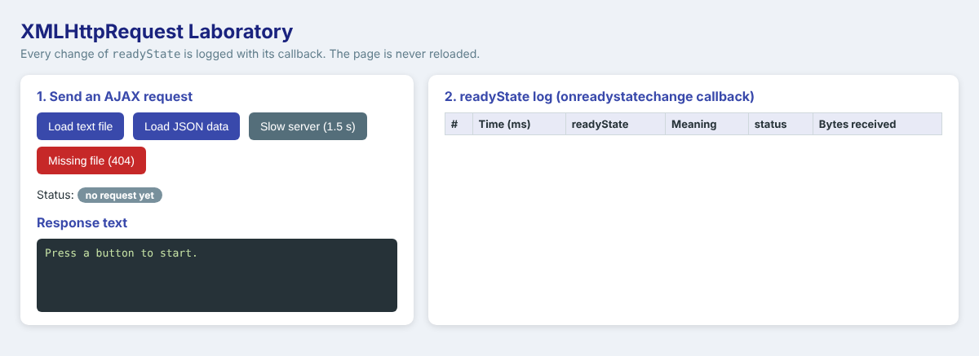
Test 2: Load text file. The log shows the state changes 1, 2, 3 and 4 and the text from info.txt appears without reloading.
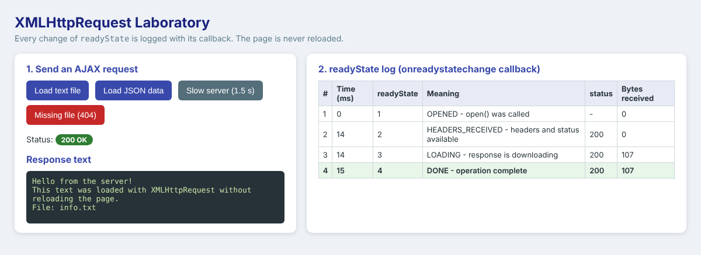
Test 3: Load JSON data. The JSON text is converted to a table by the success callback.
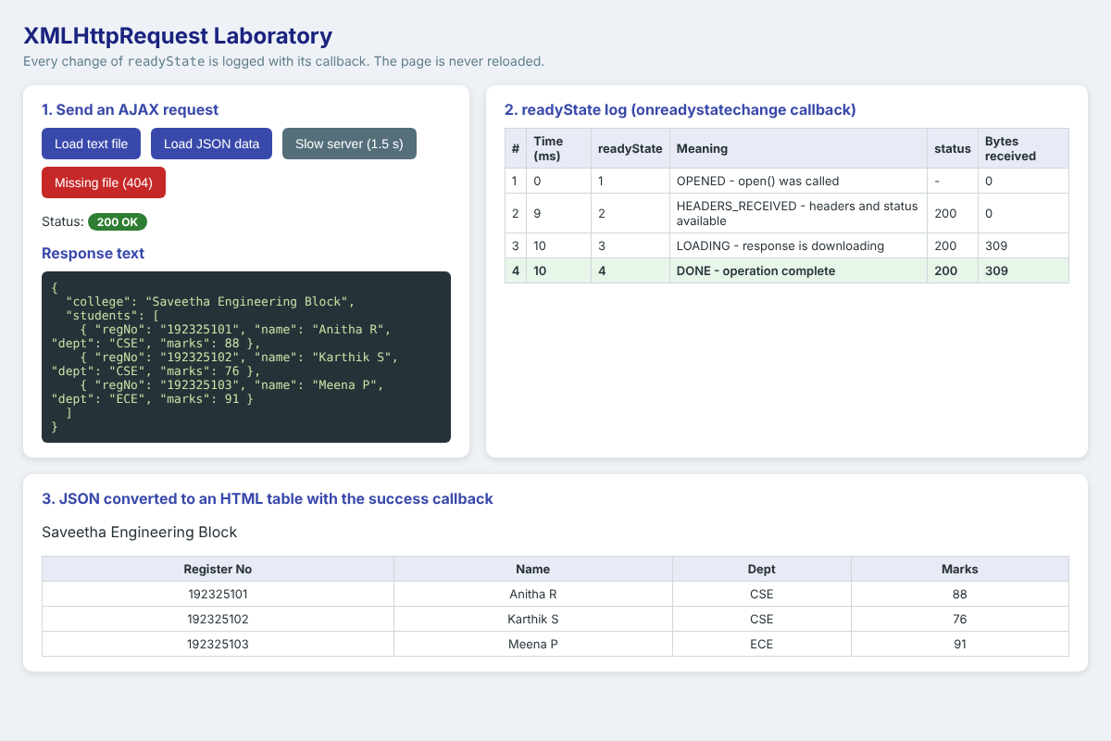
Test 4: Slow server, while waiting. Only the state OPENED has occurred, the badge shows "waiting" and the response text shows "Loading".
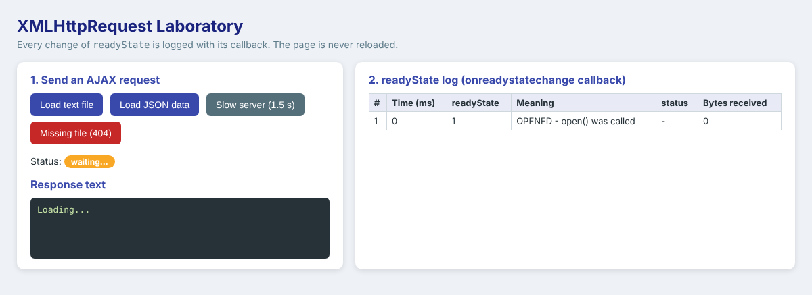
Test 5: Slow server, after 1.5 seconds. The time column shows that states 2, 3 and 4 arrived together after about 1505 ms, while state 1 was at 0 ms.
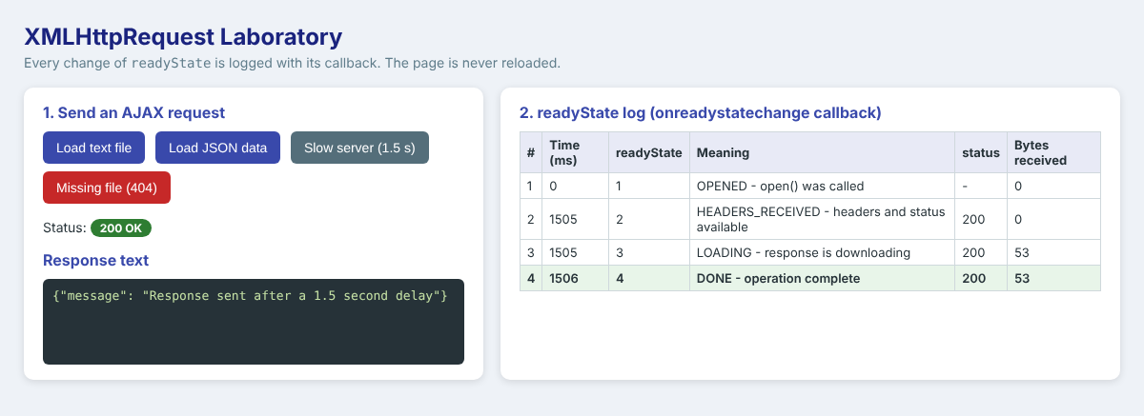
Test 6: Missing file. The server answers 404, so the failure callback is called and a red badge appears.
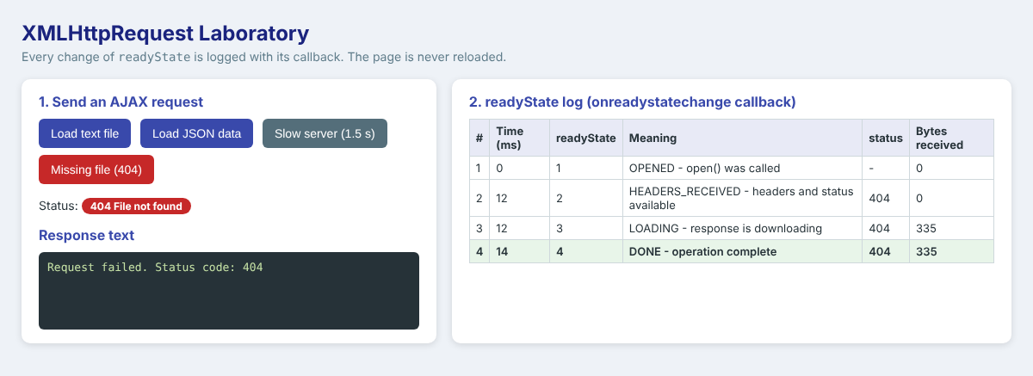

3.8 Explanation
- In every test the log starts with readyState 1 because open() was called before the callback was attached, and ends with 4. The row with state 4 is shown in green.
- The "Bytes received" column is 0 at state 2 and shows the full length at states 3 and 4, which proves that the body arrives after the headers.
- For a missing file the readyState still reaches 4, but the status is 404. This shows why the program has to check the status and not only the readyState.
- The success callback converts the JSON into a table, and the failure callback shows the red message. The AJAX code itself is the same for both.

3.9 Result
The significance of the XMLHttpRequest object, the readyState values 0 to 4 and the callback methods were discussed, and the working of AJAX was illustrated with a program that logs every state change, handles success, failure and slow responses, and updates the page without reloading it.

Question 4: Student Management System using a TypeScript Class and Object

4.1 Aim
To develop a TypeScript program that uses a class and objects to represent the details of a student (name, register number, department and marks), with properties, a constructor and a method to display the student information.

4.2 Theory

4.2.1 TypeScript
TypeScript is an open-source language developed by Microsoft. It is a superset of JavaScript that adds static types, interfaces, classes with access modifiers, generics and enums. A TypeScript file (.ts) cannot run directly in a browser; the TypeScript compiler (tsc) checks the types and transpiles the file to ordinary JavaScript (.js), which runs in any browser or in Node.js. Type errors are found while writing the program and not when the user runs it, which makes large projects safer and easier to maintain.

4.2.2 Class and Object
A class is a blueprint that describes the data (properties) and the behaviour (methods) of a kind of thing. An object is one real instance created from the class with the new keyword. Here the class Student is the blueprint and every student of the college, such as Anitha R, is an object.
Concept | Explanation | Used in student.ts
Property | A variable that belongs to the object | name, registerNumber, department, _marks
Constructor | Special method that runs when an object is created and initialises its properties | constructor(name, registerNumber, department, marks)
Method | A function that belongs to the class | displayInfo(), getGrade()
Access modifiers | public (anywhere), private (only inside the class), protected (class and subclasses) | private _marks
readonly | Value can be set only once, in the constructor | registerNumber
Getter and setter | Controlled reading and writing of a property | get marks(), set marks(value)
static | Belongs to the class and is shared by all objects | Student.totalStudents
Interface | A contract that lists the required properties | interface StudentInfo
Type annotation | Declares the type of a variable or parameter | name: string, marks: number, students: Student[]

4.3 Design of the Student Management System
Part | Details
Interface StudentInfo | name, registerNumber, department, marks
Class Student | Properties: name, registerNumber (readonly), department, _marks (private); static totalStudents
Constructor | Receives four values, validates the marks (0 to 100) and increases the student count
Method displayInfo() | Returns a text line with all the information and the grade
Method getGrade() | O (90 and above), A+ (80), A (70), B (60), C (50), Fail (below 50)
Main program | Creates four Student objects, displays them, updates marks through the setter, prints the total, the average and the topper, and tests the error handling

4.4 Program (student.ts)
Source code
// student.ts - Student Management System (TypeScript)

// 1. Interface: describes the shape of the data
interface StudentInfo {
name: string;
registerNumber: string;
department: string;
marks: number;
}

// 2. Class with properties, a constructor and methods
class Student implements StudentInfo {
static totalStudents: number = 0; // shared by all objects of the class

readonly registerNumber: string; // cannot be changed after creation
public name: string;
public department: string;
private _marks: number; // hidden from outside the class

// Constructor runs every time a new object is created
constructor(name: string, registerNumber: string, department: string, marks: number) {
this.name = name;
this.registerNumber = registerNumber;
this.department = department;
this._marks = Student.validateMarks(marks);
Student.totalStudents++;
}

// Getter and setter give controlled access to the private property
get marks(): number {
return this._marks;
}
set marks(value: number) {
this._marks = Student.validateMarks(value);
}

private static validateMarks(value: number): number {
if (value < 0 || value > 100) {
throw new Error("Marks must be between 0 and 100, received " + value);
}
return value;
}

// Method that returns a grade
getGrade(): string {
if (this._marks >= 90) return "O";
if (this._marks >= 80) return "A+";
if (this._marks >= 70) return "A";
if (this._marks >= 60) return "B";
if (this._marks >= 50) return "C";
return "Fail";
}

// Method to display the student information
displayInfo(): string {
return "Name: " + this.name +
" | Reg No: " + this.registerNumber +
" | Dept: " + this.department +
" | Marks: " + this._marks +
" | Grade: " + this.getGrade();
}
}

// 3. Creating objects of the class
const s1: Student = new Student("Anitha R", "192325101", "CSE", 88);
const s2: Student = new Student("Karthik S", "192325102", "CSE", 76);
const s3: Student = new Student("Meena P", "192325103", "ECE", 93);
const s4: Student = new Student("Ravi K", "192325104", "IT", 48);

const students: Student[] = [s1, s2, s3, s4];

// 4. Display student information
console.log("===== STUDENT MANAGEMENT SYSTEM =====");
students.forEach((s: Student): void => console.log(s.displayInfo()));

// 5. Update marks using the setter, then display again
s2.marks = 84;
console.log("\nAfter updating marks of " + s2.name + ":");
console.log(s2.displayInfo());

// 6. Simple report
const total: number = students.reduce((sum: number, s: Student): number => sum + s.marks, 0);
const average: number = total / students.length;
const topper: Student = students.reduce((a: Student, b: Student): Student => (a.marks >= b.marks ? a : b));

console.log("\nTotal students : " + Student.totalStudents);
console.log("Average marks : " + average.toFixed(2));
console.log("Topper : " + topper.name + " (" + topper.marks + ")");

// 7. Error handling: the setter rejects invalid marks
try {
s4.marks = 120;
} catch (e) {
console.log("Error caught : " + (e as Error).message);
}

// 8. Show the same data in a web page when the script is loaded in a browser
// (the "DOM" library of TypeScript supplies the type of document)
if (typeof document !== "undefined") {
const body: string = students.map((s: Student): string =>
"<tr><td>" + s.registerNumber + "</td><td>" + s.name + "</td><td>" + s.department + "</td><td>" + s.marks + "</td><td>" + s.getGrade() + "</td></tr>").join("");
document.getElementById("rows")!.innerHTML = body;
document.getElementById("summary")!.textContent =
"Total students: " + Student.totalStudents + " | Average marks: " + average.toFixed(2) + " | Topper: " + topper.name;
}

4.5 Web Page that Uses the Compiled Script (q4.html)
Source code
<!DOCTYPE html>
<html lang="en">
<head>
<meta charset="UTF-8">
<link rel="icon" href="data:,">
<title>Student Management System | TypeScript</title>
<style>
body { margin: 0; padding: 30px; font-family: "Segoe UI", Arial, sans-serif; background: #f3f6fb; }
.box { max-width: 760px; margin: 0 auto; background: #fff; border-radius: 10px; padding: 20px 26px; box-shadow: 0 3px 12px rgba(0, 0, 0, .13); }
h1 { margin: 0 0 4px; font-size: 22px; color: #0d47a1; }
p { color: #607d8b; font-size: 14px; margin: 0 0 14px; }
table { width: 100%; border-collapse: collapse; }
th, td { border: 1px solid #cfd8dc; padding: 8px 10px; text-align: center; }
th { background: #0d47a1; color: #fff; }
tr:nth-child(even) td { background: #f5f9ff; }
#summary { margin-top: 14px; font-weight: 600; color: #1b5e20; }
</style>
</head>
<body>
<div class="box">
<h1>Student Management System</h1>
<p>Table generated by <b>student.js</b>, which was compiled from <b>student.ts</b> with the TypeScript compiler.</p>
<table>
<thead><tr><th>Register No</th><th>Name</th><th>Department</th><th>Marks</th><th>Grade</th></tr></thead>
<tbody id="rows"></tbody>
</table>
<div id="summary"></div>
</div>
<script src="student.js"></script>
</body>
</html>

4.6 Compilation and Execution Steps
- Install TypeScript: npm install -g typescript (checked with tsc -v).
- Compile: tsc student.ts --target ES2017 --lib ES2017,DOM. This checks the types and creates student.js.
- Run in Node.js: node student.js.
- Run in the browser: open q4.html, which loads student.js with a script tag.

4.7 Output
Compilation and execution in the terminal. The compiler reported no errors and Node.js printed the student information.
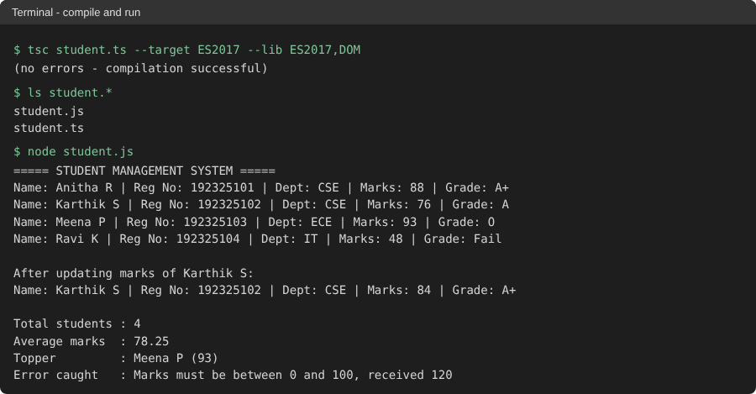
The same data in the web browser. The table was produced by the compiled student.js.
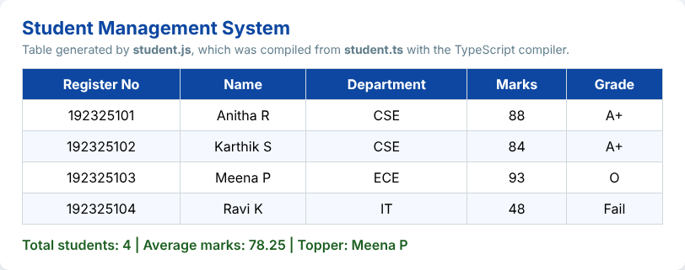
The JavaScript generated by the compiler (first lines of student.js). The types and the access modifiers were removed, and the class remained as ordinary JavaScript.
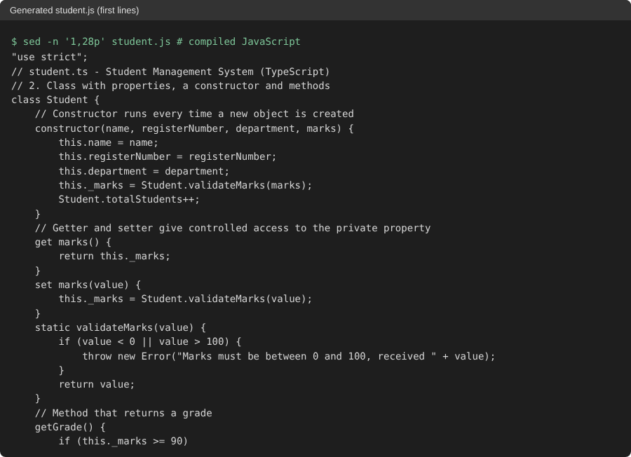

4.8 Explanation of the Output
- Four objects, s1 to s4, were created with the constructor. Every object has its own name, register number, department and marks.
- displayInfo() returned one line for each student, and getGrade() was called inside it. For example 93 marks gives grade O and 48 marks gives Fail.
- The setter changed the marks of Karthik S from 76 to 84, and the grade changed from A to A+. This shows encapsulation: the marks are changed only through the setter that checks the range.
- Student.totalStudents is a static property, and it was 4 after four objects. The average (88 + 84 + 93 + 48) / 4 = 78.25 and the topper Meena P were calculated from the array of objects.
- The assignment s4.marks = 120 threw an error that was caught by try and catch, and the message "Marks must be between 0 and 100" was printed.

4.9 Result
A Student Management System was developed in TypeScript using an interface, a class with properties, a constructor, getters and setters, and methods. The program was compiled with tsc without errors, and it ran correctly in Node.js and in the browser.

Question 5: Online Banking Form Validation using JavaScript and Regular Expressions

5.1 Aim
To develop a JavaScript-based form validation system for an online banking application that uses regular expressions to validate the account number, mobile number and email ID.

5.2 Theory
Banking forms must reject wrong data before it is sent to the server. Client-side validation gives the customer an instant message and saves a round trip to the server. It must always be repeated on the server, because a user can bypass the browser checks, but the first check in the browser improves the speed and the experience. Regular expressions are the standard tool for this work, because a pattern describes the exact format of the data.

5.2.1 Rules for the three fields
Field | Rule used | Pattern
Account number | Digits only; 9 to 18 digits (the length range of Indian bank accounts); the first digit is not 0 | /^[1-9][0-9]{8,17}$/
Mobile number | 10 digits; first digit 6, 7, 8 or 9; optional +91 or 0 prefix | /^(?:\+91|0)?[6-9][0-9]{9}$/
Email ID | Local part, @, domain name, a dot and an extension of at least two letters | /^[A-Za-z0-9._%+-]+@[A-Za-z0-9-]+(?:\.[A-Za-z0-9-]+)*\.[A-Za-z]{2,}$/

5.2.2 Explanation of the patterns
- Account number. [1-9] accepts a non-zero first digit, and [0-9]{8,17} accepts 8 to 17 more digits, which gives 9 to 18 digits in total. ^ and $ make sure that there are no letters or spaces anywhere in the text.
- Mobile number. (?:\+91|0)? is an optional group for the country code or the trunk zero, [6-9] is the first digit and [0-9]{9} are the remaining nine digits.
- Email ID. [A-Za-z0-9._%+-]+ is the user name, @ is the separator, [A-Za-z0-9-]+ is the first part of the domain, (?:\.[A-Za-z0-9-]+)* allows sub-domains such as co.in, and \.[A-Za-z]{2,} is the final extension.

5.3 Algorithm
- Read the three input values and remove spaces from both ends with trim().
- If a value is empty, show "is required"; otherwise test it with the regular expression of that field.
- Show the error text below the field and mark the input red; if it is valid, mark it green and clear the message.
- On submit, call preventDefault() and validate all three fields (not only the first wrong one).
- If all are valid, show the success message with the last four digits of the account number; otherwise list the invalid fields.
- The Clear button removes the colours and messages.

5.4 Program (q5.html)
Source code
<!DOCTYPE html>
<html lang="en">
<head>
<meta charset="UTF-8">
<meta name="viewport" content="width=device-width, initial-scale=1.0">
<link rel="icon" href="data:,">
<title>SecureBank | Beneficiary Form Validation</title>
<style>
* { box-sizing: border-box; }
body { margin: 0; font-family: "Segoe UI", Arial, sans-serif; background: #eaf1f8; color: #1c2a39; }
header { background: #0b3d6b; color: #fff; padding: 16px 40px; display: flex; justify-content: space-between; align-items: center; }
header h1 { margin: 0; font-size: 24px; letter-spacing: .5px; }
header span { font-size: 13px; color: #9ec5e8; }
.layout { display: grid; grid-template-columns: 1.1fr 1fr; gap: 22px; max-width: 1050px; margin: 26px auto; padding: 0 20px; }
.card { background: #fff; border-radius: 10px; padding: 22px 26px; box-shadow: 0 2px 10px rgba(11, 61, 107, .14); }
h2 { margin: 0 0 14px; font-size: 18px; color: #0b3d6b; }
.row { margin-bottom: 14px; }
label { display: block; font-size: 14px; font-weight: 600; margin-bottom: 4px; }
input { width: 100%; padding: 10px 12px; font-size: 15px; border: 2px solid #c5d3e0; border-radius: 6px; outline: none; }
input:focus { border-color: #1976d2; }
input.ok { border-color: #2e7d32; background: #f3faf3; }
input.bad { border-color: #c62828; background: #fff6f6; }
.hint { font-size: 12px; color: #78909c; margin-top: 3px; }
.err { font-size: 13px; color: #c62828; margin-top: 3px; min-height: 17px; }
button { background: #0b3d6b; color: #fff; border: 0; padding: 11px 24px; border-radius: 6px; font-size: 15px; font-weight: 600; cursor: pointer; }
button.alt { background: #78909c; margin-left: 8px; }
#result { margin-top: 16px; padding: 12px 14px; border-radius: 6px; font-size: 14px; display: none; }
#result.good { background: #e8f5e9; color: #1b5e20; border: 1px solid #81c784; display: block; }
#result.fail { background: #ffebee; color: #b71c1c; border: 1px solid #ef9a9a; display: block; }
table { width: 100%; border-collapse: collapse; font-size: 13px; }
th, td { border: 1px solid #cfd8dc; padding: 6px 8px; text-align: left; vertical-align: top; }
th { background: #e3edf7; }
code { font-family: Consolas, monospace; font-size: 12px; background: #f1f4f7; padding: 1px 4px; border-radius: 3px; }
</style>
</head>
<body>
<header><h1>SecureBank Online</h1><span>Add Beneficiary &bull; Secure session</span></header>

<div class="layout">
<div class="card">
<h2>Add New Beneficiary</h2>
<form id="bankForm" novalidate>
<div class="row">
<label for="acc">Account Number</label>
<input id="acc" type="text" inputmode="numeric" placeholder="9 to 18 digits" autocomplete="off">
<div class="hint">Digits only, 9 to 18 digits, must not start with 0.</div>
<div class="err" id="acc-e"></div>
</div>
<div class="row">
<label for="mob">Registered Mobile Number</label>
<input id="mob" type="text" inputmode="tel" placeholder="e.g. 9876543210" autocomplete="off">
<div class="hint">10 digits starting with 6, 7, 8 or 9 (+91 or 0 prefix allowed).</div>
<div class="err" id="mob-e"></div>
</div>
<div class="row">
<label for="mail">Email ID</label>
<input id="mail" type="text" placeholder="name@bank.com" autocomplete="off">
<div class="hint">Format: name@domain.extension</div>
<div class="err" id="mail-e"></div>
</div>
<button type="submit">Validate &amp; Submit</button>
<button type="reset" class="alt" id="reset">Clear</button>
</form>
<div id="result"></div>
</div>

<div class="card">
<h2>Regular Expressions Used</h2>
<table>
<tr><th>Field</th><th>Pattern</th></tr>
<tr><td>Account number</td><td><code>/^[1-9][0-9]{8,17}$/</code></td></tr>
<tr><td>Mobile number</td><td><code>/^(?:\+91|0)?[6-9][0-9]{9}$/</code></td></tr>
<tr><td>Email ID</td><td><code>/^[A-Za-z0-9._%+-]+@[A-Za-z0-9-]+(?:\.[A-Za-z0-9-]+)*\.[A-Za-z]{2,}$/</code></td></tr>
</table>
<h2 style="margin-top:18px">Pattern Parts</h2>
<table>
<tr><th>Symbol</th><th>Meaning</th></tr>
<tr><td><code>^ $</code></td><td>Start and end of the whole text</td></tr>
<tr><td><code>[6-9]</code></td><td>One character from the range</td></tr>
<tr><td><code>{9}</code>, <code>{8,17}</code></td><td>Exact count or minimum and maximum count</td></tr>
<tr><td><code>(?:...)?</code></td><td>Optional non-capturing group</td></tr>
<tr><td><code>+ *</code></td><td>One or more, zero or more</td></tr>
<tr><td><code>\.</code></td><td>A literal dot</td></tr>
</table>
</div>
</div>

<script>
var PATTERNS = {
acc: { re: /^[1-9][0-9]{8,17}$/, empty: 'Account number is required.', bad: 'Invalid account number. Enter 9 to 18 digits without spaces or letters, and not starting with 0.' },
mob: { re: /^(?:\+91|0)?[6-9][0-9]{9}$/, empty: 'Mobile number is required.', bad: 'Invalid mobile number. It must have 10 digits and start with 6, 7, 8 or 9.' },
mail: { re: /^[A-Za-z0-9._%+-]+@[A-Za-z0-9-]+(?:\.[A-Za-z0-9-]+)*\.[A-Za-z]{2,}$/, empty: 'Email ID is required.', bad: 'Invalid email ID. Use the format name@domain.com.' }
};

function validate(id) {
var el = document.getElementById(id), err = document.getElementById(id + '-e');
var v = el.value.trim(), p = PATTERNS[id], ok = false, text = '';
if (v === '') text = p.empty;
else if (!p.re.test(v)) text = p.bad;
else ok = true;
el.className = ok ? 'ok' : 'bad';
err.textContent = text;
return ok;
}

Object.keys(PATTERNS).forEach(function (id) {
document.getElementById(id).addEventListener('blur', function () { validate(id); });
document.getElementById(id).addEventListener('input', function () { if (this.className) validate(id); });
});

document.getElementById('bankForm').addEventListener('submit', function (e) {
e.preventDefault();
var r = document.getElementById('result');
var a = validate('acc'), m = validate('mob'), em = validate('mail');
if (a && m && em) {
var acc = document.getElementById('acc').value.trim();
r.className = 'good';
r.textContent = 'All details are valid. Beneficiary account ending ' + acc.slice(-4) + ' will be added after OTP verification.';
} else {
r.className = 'fail';
r.textContent = 'Form not submitted: ' + [a ? '' : 'account number', m ? '' : 'mobile number', em ? '' : 'email ID'].filter(Boolean).join(', ') + ' invalid.';
}
});

document.getElementById('reset').addEventListener('click', function () {
['acc', 'mob', 'mail'].forEach(function (id) { document.getElementById(id).className = ''; document.getElementById(id + '-e').textContent = ''; });
document.getElementById('result').className = '';
});
</script>
</body>
</html>

5.5 Output
Test 1: Page when it is opened. The table on the right explains the regular expressions.
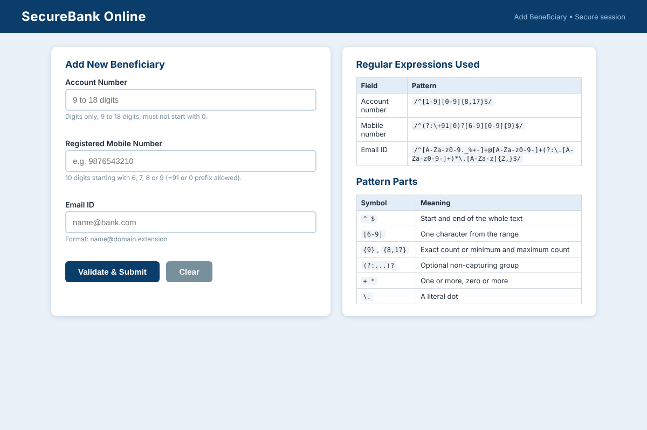
Test 2: Submit with all fields empty.
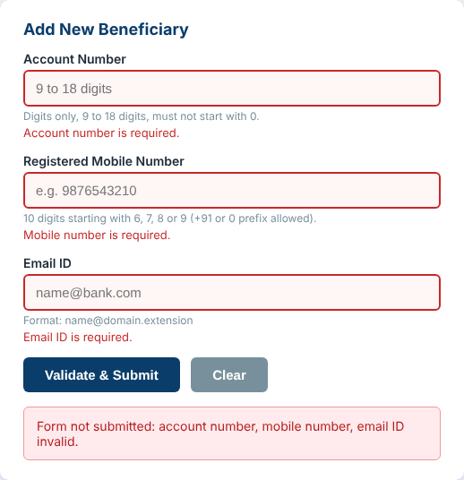
Test 3: All three values wrong. Account number with letters and a leading zero, a mobile number starting with 5, and an email with two @ symbols.
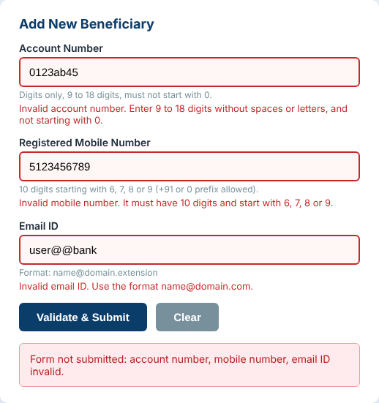
Test 4: Account number and email correct, mobile number too short. Only the mobile number is reported.
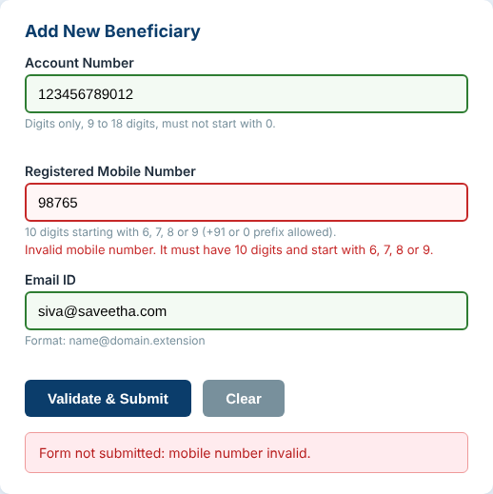
Test 5: All values correct (mobile number entered with the +91 prefix).
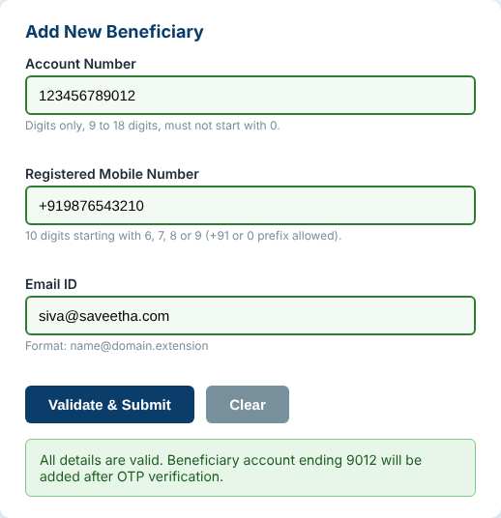

5.6 Regular Expression Test Results
The patterns were also executed in the browser with sample strings. The results are from the running page.
Field | Test string | Expected | Result of test()
Account | 123456789 (9 digits) | Valid | true
Account | 12345678 (8 digits) | Invalid | false
Account | 012345678 (starts with 0) | Invalid | false
Account | 1234567890123456789 (19 digits) | Invalid | false
Mobile | 9876543210 | Valid | true
Mobile | +919876543210 | Valid | true
Mobile | 09876543210 | Valid | true
Mobile | 1234567890 (starts with 1) | Invalid | false
Email | x@y.com | Valid | true
Email | x@y (no extension) | Invalid | false
Email | x y@z.com (space) | Invalid | false

5.7 Explanation
- Each field shows its own message, so the customer knows exactly what to correct. In Test 3 all three messages were shown at the same time.
- In Test 4 the account number and email were green and only the mobile number was red, which proves that every field is validated independently.
- The success message shows only the last four digits of the account number, which is how banks avoid displaying a full account number on the screen.
- The page did not reload at any step, because the submit event was handled with preventDefault().

